URANQUINTY VILLAGE GARAGE SALE
Saturday 23 October 2021
10kms south of Wagga on the Olympic Highway

Vans: AUSSIE BOB’S ICE CREAM, Albury Mobile Sharpening, CJ’s Hair Rescue with makeup artist, Tato Tornado, The Good Grind Coffee, face painting (tbc)
Men’s Shed: Pianola for restoration – sausage sizzle

Stallholder hire fee $15
Applications: Rhonda E:roopalmer81@gmail.com or collect from Post Office
VILLAGE GARAGE SALE
8am – 4pm
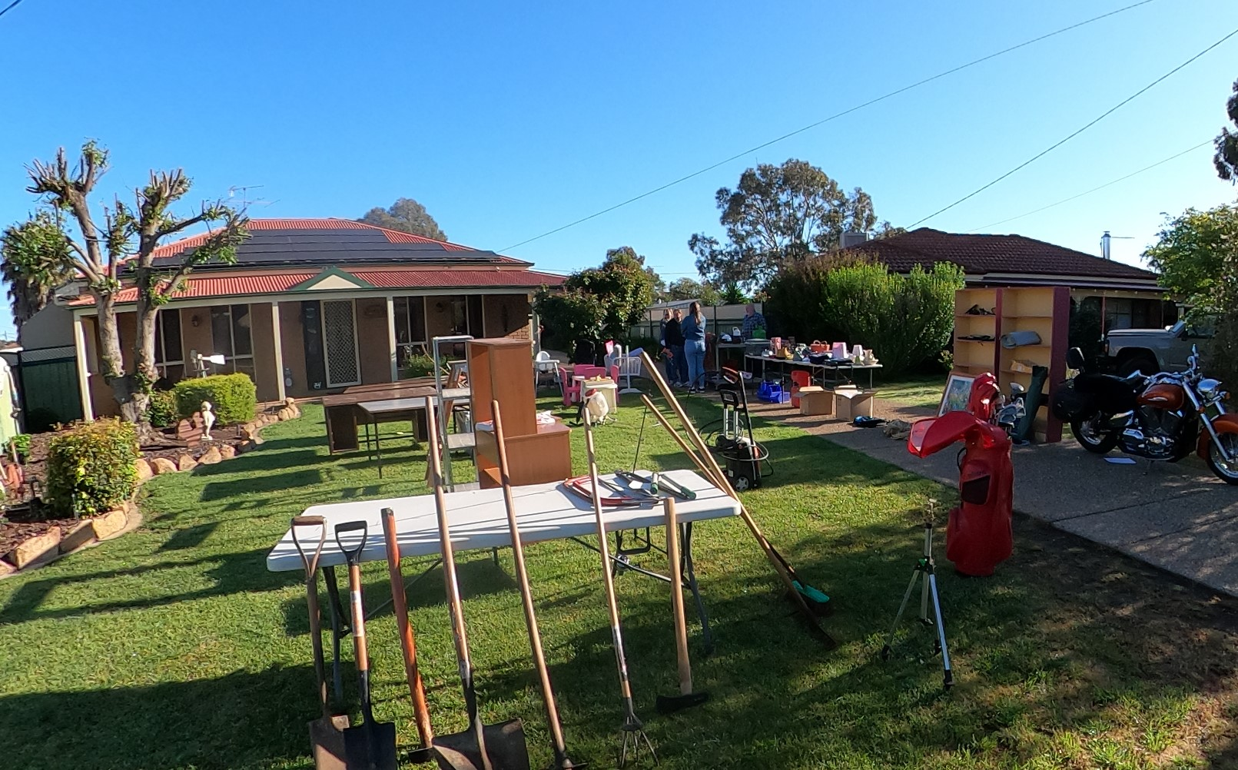

Maps will be available at the Quinty Bakery on 22 October
Fee: $15 per house for advertising. COVID rules: each house is responsible for its own safety plan but an updated advice sheet will be provided with your poster and balloons
Submissions close Friday 9 October (put completed submissions in the red box at the Post Office)

Supported by Uranquinty Progress Association and
Origin Energy

